

**Table of contents**

**1. Overview 3**

1.1. Glossary 3

1.2. Purpose 3

1.3. Minimum device configuration 3

**2. Instructions for installing the application 3**

2.1. Android version 3

2.2. iOS version 4

**3. Instructions for using the application 4**

3.1. Login 4

3.2. Create Account 5

3.2.1. Create a Provincial Fund account 5

3.2.2. Create a Forest Owner account 5

3.2.3. Create a Commune Owner (CPC) account 6

3.2.4. Create a Community Management Member (CBM) account 7

3.2.5. Create a Community Member (CM) account 7

3.3. Fill out and submit the forms 8

3.3.1. Form for Proposal of livelihood development activities 8

3.3.2. Community meeting minutes form 9

3.3.3. Livelihood development project plan form 9

3.3.4. Community income and expenditure book form 10

3.4. Browse the Livelihood Development Project Plan form 11

3.4.1. Select browse form from the Notifications screen 11

3.4.2. Select to approving forms from the List forms screen 12

# Overview

## **1.1. Glossary**

| **#** | **Term** | **Definition** |
| --- | --- | --- |
| 1 | MRV | Measurement, reporting and verification |
| 2 | CPC | Commune People's Committee |
| 3 | CBM | Community Board Member |
| 4 | CM | Community member |
| 5 | App | Karbon Map App |

## **1.2. Purpose**

App Karbon Map is an application that allows community members to easily participate in the MRV process of reducing greenhouse gas emissions, making forest data transparent and available for everyone to verify and audit, easy for large-scale land and forest project managers, allowing project managers and researchers to access raw data to assess and calculate aggregated carbon stocks for management and report.

## **1.3. Minimum device configuration**

To use the Karbon Map app, the minimum device configuration requirements are as follows

* Android: Android 7.0 or higher
* iOS: iOS 11.3 or higher

# Instructions for installing the application

## **2.1. Android version**

Step 1: Visit the following link or scan the QR code

Link: [Download Android version app](https://drive.google.com/file/d/1Yvj9lxb0vSdu_MgcSCWmGeWMaKPlRaO2/view?usp=sharing)

QR code:



Step 2: Download the file in the link.

Step 3: Open the file in the phone. Install files.

Step 4: Return to the main screen. Open the app and log in

## **2.2. iOS version**

Step 1: Visit the following link or scan the QR code

Link: [Download iOS version app](https://docs.google.com/document/d/1wzJ6uswJXO_OlQAOa2rvgF-gWmbUD79kh6ma5nI6kTI/edit?usp=sharing)

QR code:

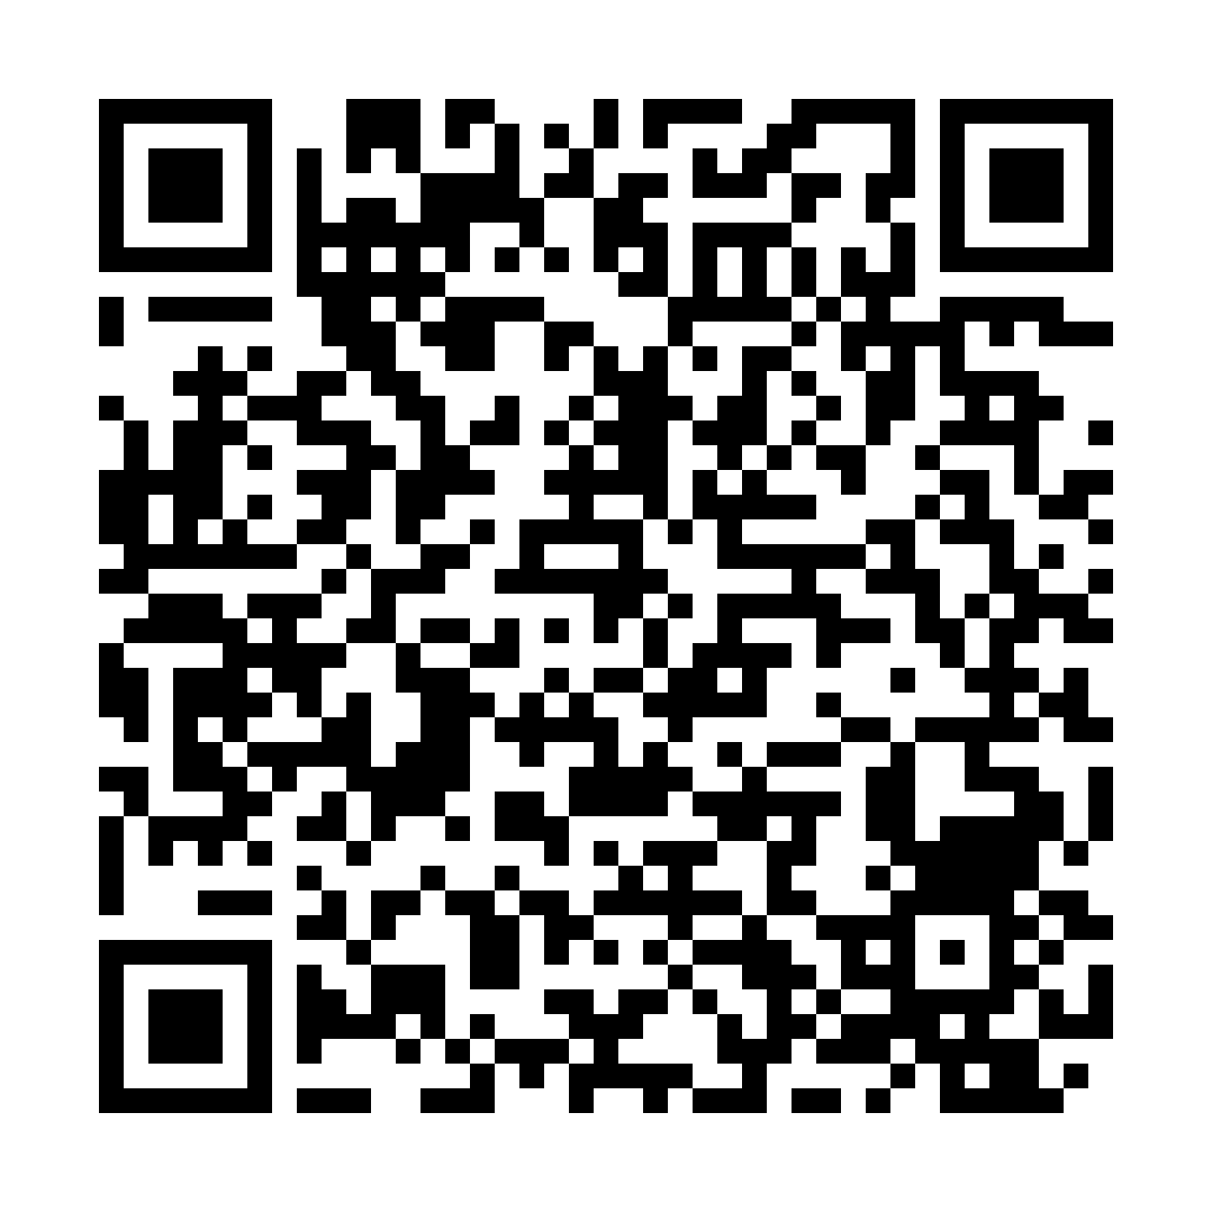

Step 2: Follow the instructions.

Step 3: Return to the main screen. Open the app and log in

# Instructions for using the application

## **3.1. Login**

Step 1: At the Smartphone screen, select the **Karbon Map** application

Step 2: At the Login screen, enter *Username*. Click the **Continue** button

Step 3: At the Login screen, enter *Password*. Click the **Login** button

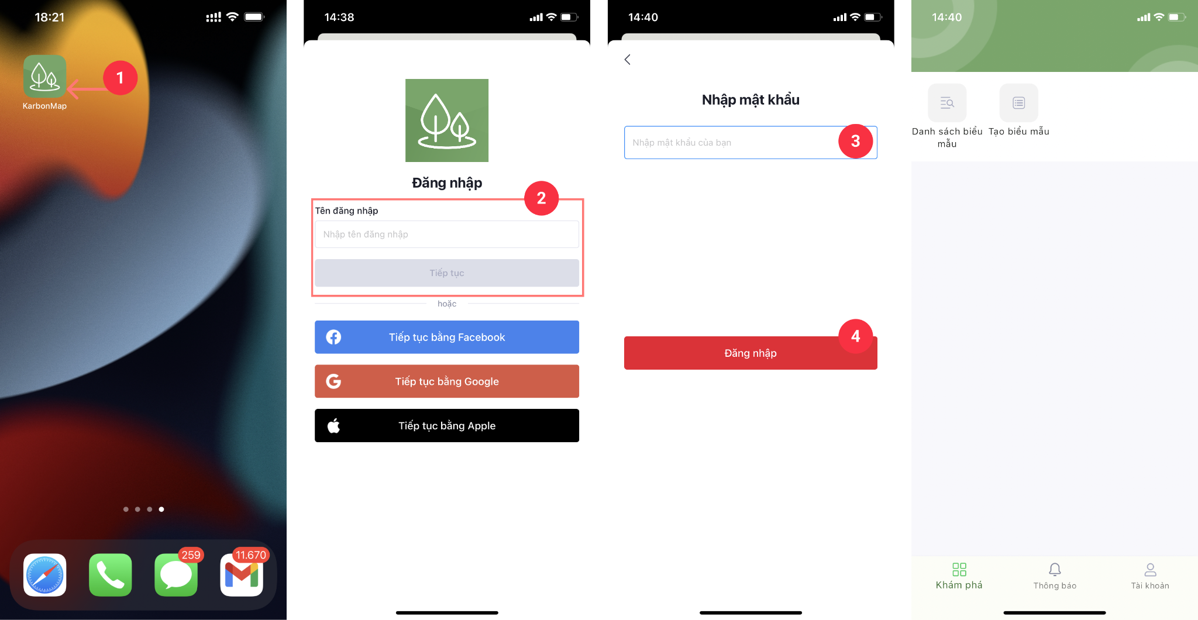Upon successful login, the application displays the main screen of **Karbon Map**

## **3.2. Create Account**

### 3.2.1. Create Provincial Fund account

**Description**: Teko admin creates Provincial Fund account

Step 1: At the main screen of the app, select the **Create form** icon

Step 2: At the Select form screen, select the Administrator Registration Form. Click the **Add new form** button

Step 3: At the Add new form screen, fill in the information in the form. Complete, confirm and press the **Approve** button

*Note: Information (*) is required to be entered/selected*

### **3.2.2.** Create Forest Owner account

**Description**: The Provincial Fund creates Forest Owner account

Step 1: At the main screen of the app, select the **Create form** icon

Step 2: At the Select form screen, select the Administrator Registration Form. Click the **Add new form** button

Step 3: At the Add new form screen, fill in the information in the form. Complete, confirm and press the **Approve** button

*Note: Information (*) is required to be entered/selected*

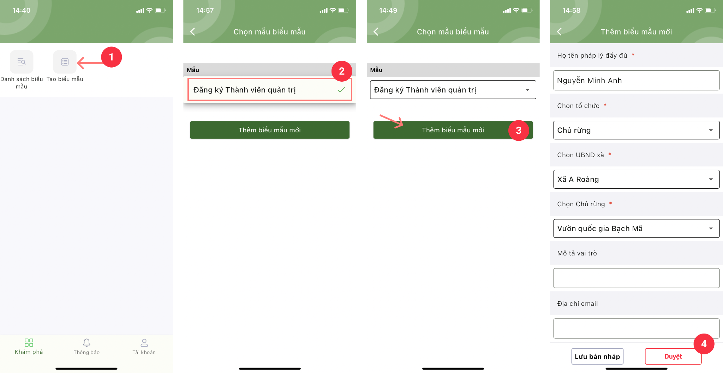

### 

### **3.2.3.** Create Commune People Committee (CPC) account

**Description**: Forest owner creates CPC account

Step 1: At the main screen of the app, select the **Create form** icon

Step 2: At the Select form screen, select the Administrator Registration Form. Click the **Add new form** button

Step 3: At the Add new form screen, fill in the information in the form. Complete, confirm and press the **Approve** button

*Note: Information (*) is required to be entered/selected*

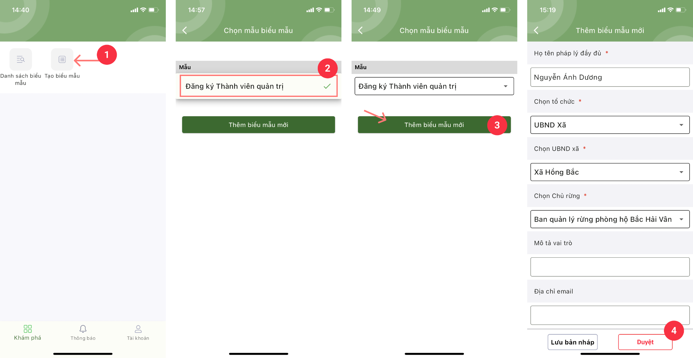

### **3.2.4.** Create Community Board Member (CBM) account

**Description**: CPC creates Community Board Member account

Step 1: At the main screen of the app, select the **Create form** icon

Step 2: At the Select form screen, select the Community Board Member Registration Form. Click the **Add new form** button

Step 3: At the Add new form screen, fill in the information in the form. Complete, confirm and press the **Approve** button

*Note: Information (*) is required to be entered/selected*

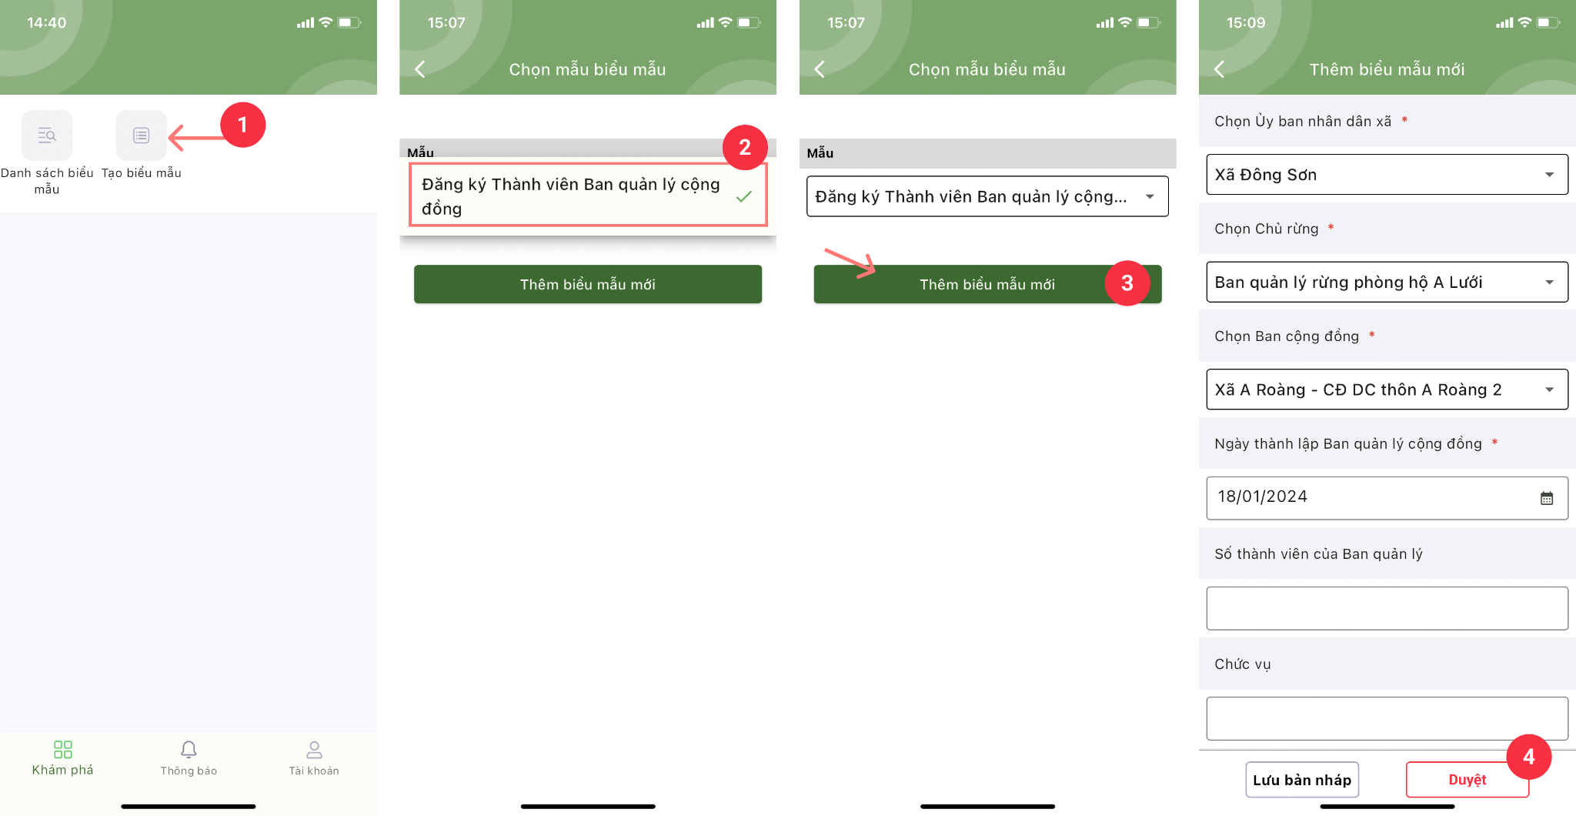

### **3.2.5.** Create Community Member (CM) account

**Description**: Community Board Members create Community Member accounts

Step 1: At the main screen of the app, select the **Create form** icon

Step 2: At the Select form screen, select the Community Member Registration Form. Click the **Add new form** button

Step 3: At the Add new form screen, fill in the information in the form. Complete, confirm and press the **Approve** button

*Note: Information (*) is required to be entered/selected*

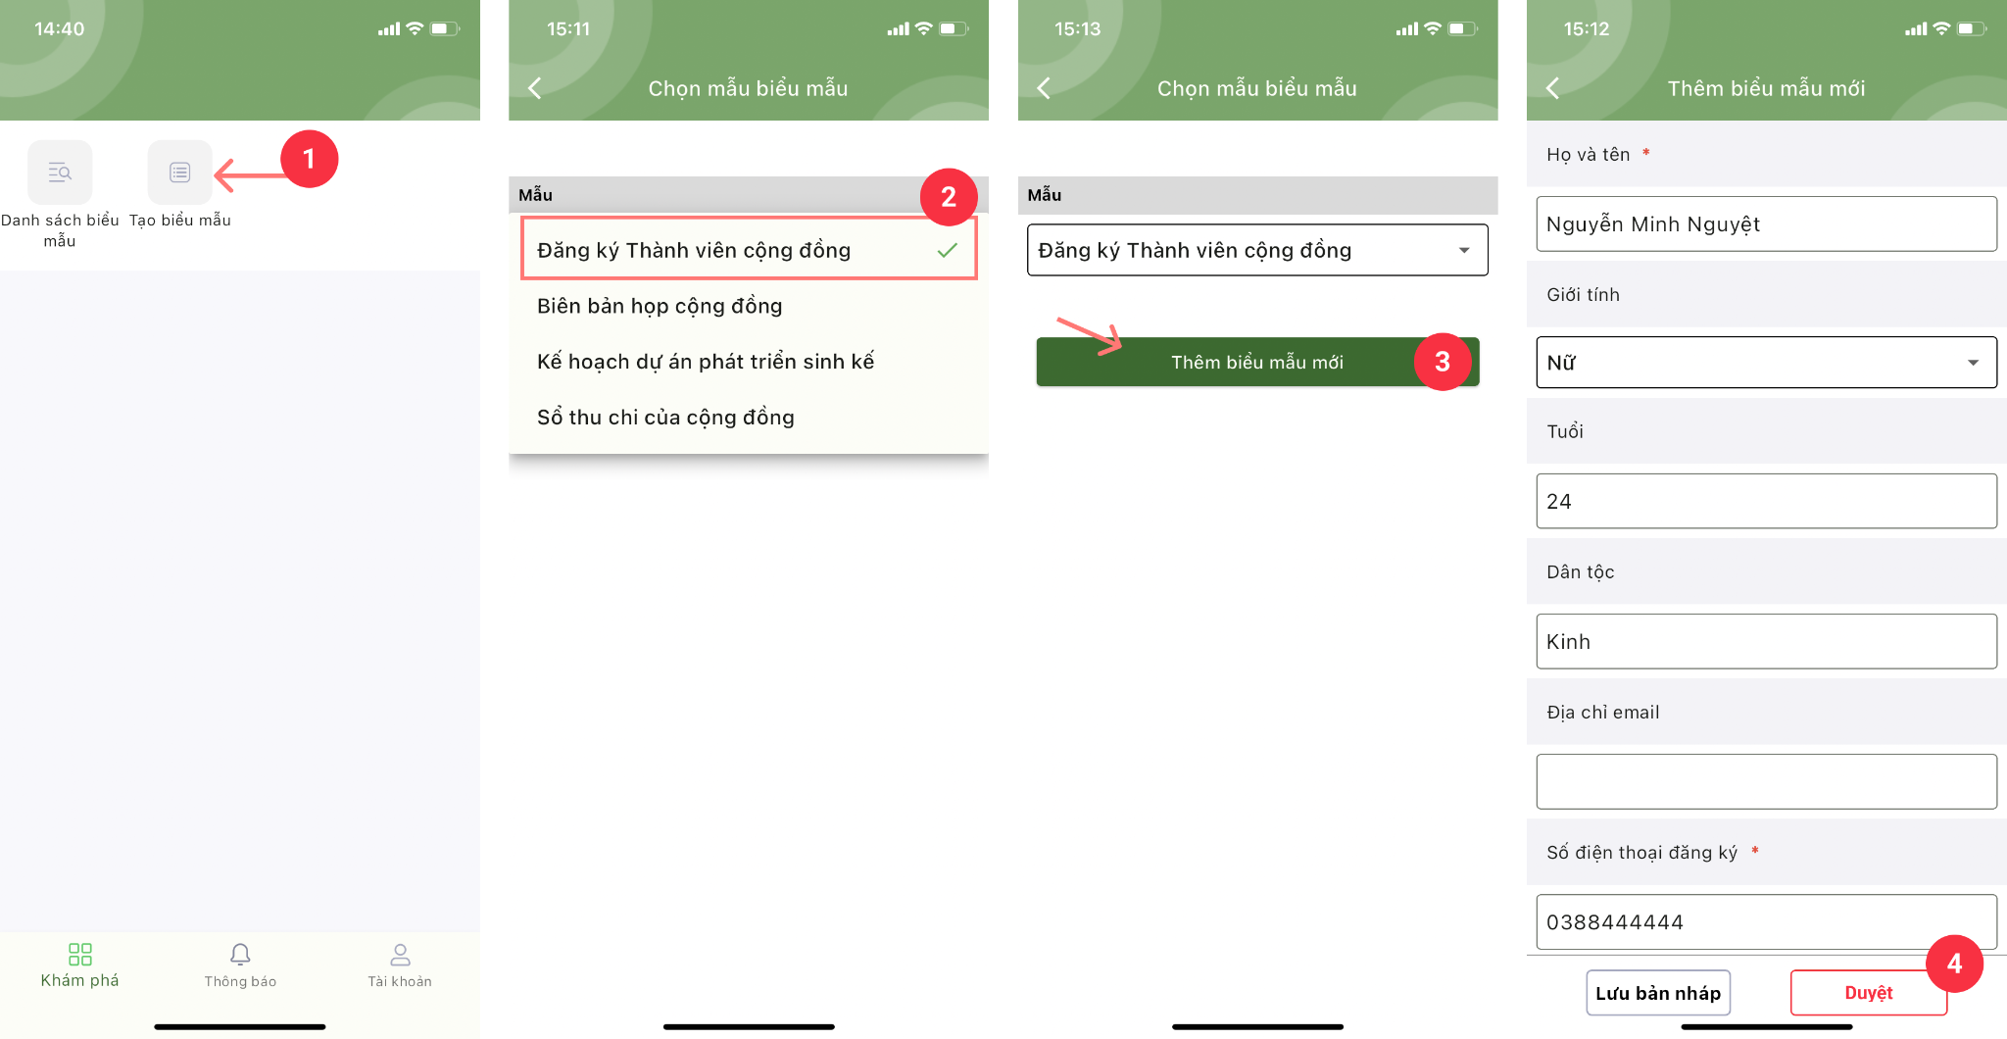

## **3.3. Fill out and submit the forms**

### **3.3.1.** Form for Proposal of livelihood development activities

Description: Form created and submitted for approval by a community member

Step 1: At the main screen of the app, select the Create form icon

Step 2: At the Choose form screen, select the form Proposing livelihood development activities. Click the Add new form button

Step 3: At the Add new form screen, fill in the information in the form. Complete, confirm and press the Approve button

*Note: Information (*) is required to be entered/selected*

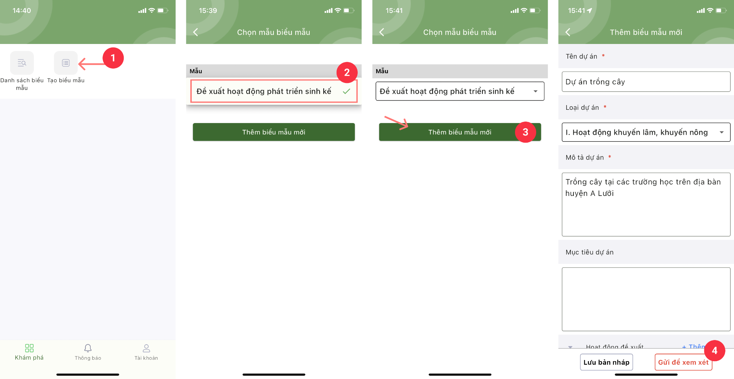

### **3.3.2.** Community meeting minutes form

Description: Form created and submitted for approval by a Community Management Board Member

Step 1: At the main screen of the app, select the Create form icon

Step 2: At the Choose form screen, select the Community meeting minutes form. Click the Add new form button

Step 3: At the Add new form screen, fill in the information in the form. Complete, confirm and press the Approve button

*Note: Information (*) is required to be entered/selected*

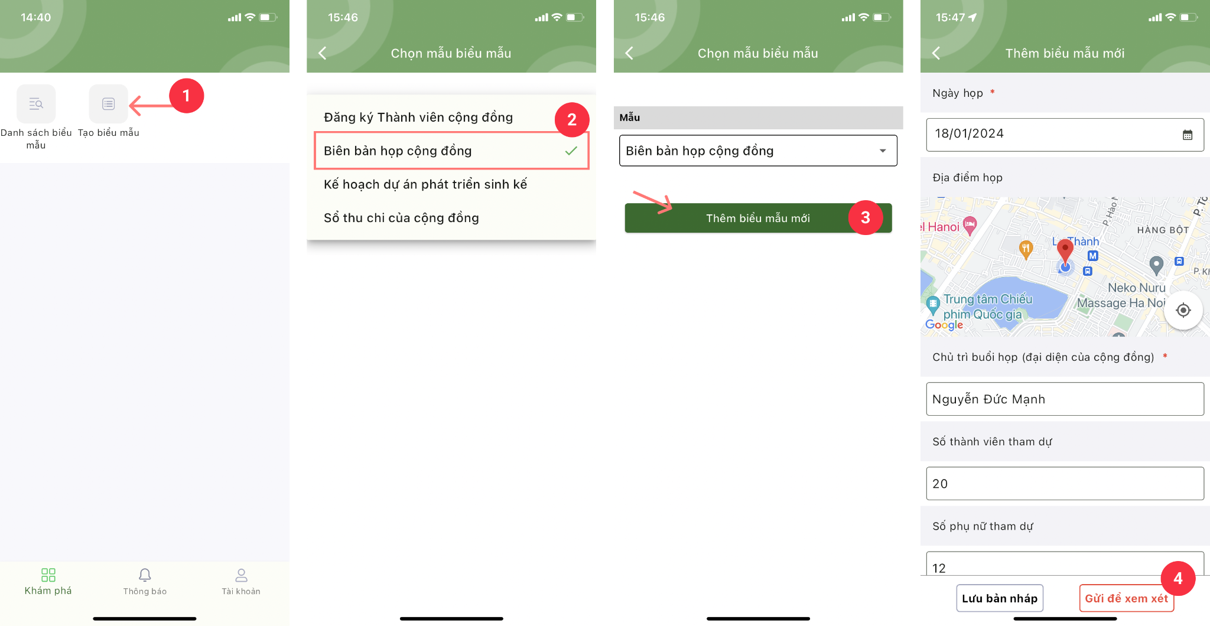

### 

### **3.3.3.** Livelihood development project plan form

**Description:** Form created and submitted for approval by a Community Management Board Member

Step 1: At the main screen of the app, select the Create form icon

Step 2: At the Choose form screen, select the Livelihood development project plan form. Click the Add new form button

Step 3: At the Add new form screen, fill in the information in the form. Complete, confirm and press the Approve button

*Note: Information (*) is required to be entered/selected*

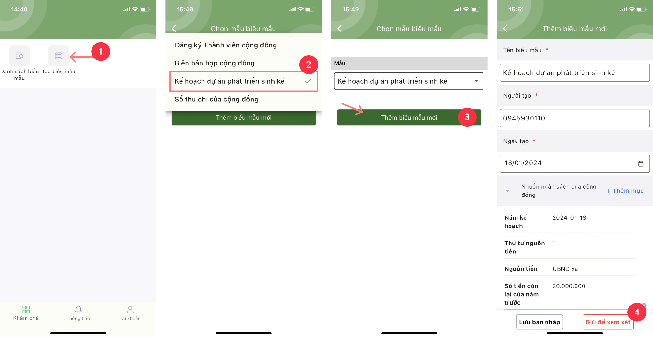

### 

### **3.3.4.** Community income and expenditure book form

**Description: Form created and submitted for approval by a Community Management Board Member**

**Step 1: At the main screen of the app, select the Create form icon**

**Step 2: At the Choose form screen, select the Community Receipt and Expenditure Book form. Click the Add new form button**

**Step 3: At the Add new form screen, fill in the information in the form. Complete, confirm and press the Approve button**

*Note: Information (*) is required to be entered/selected*

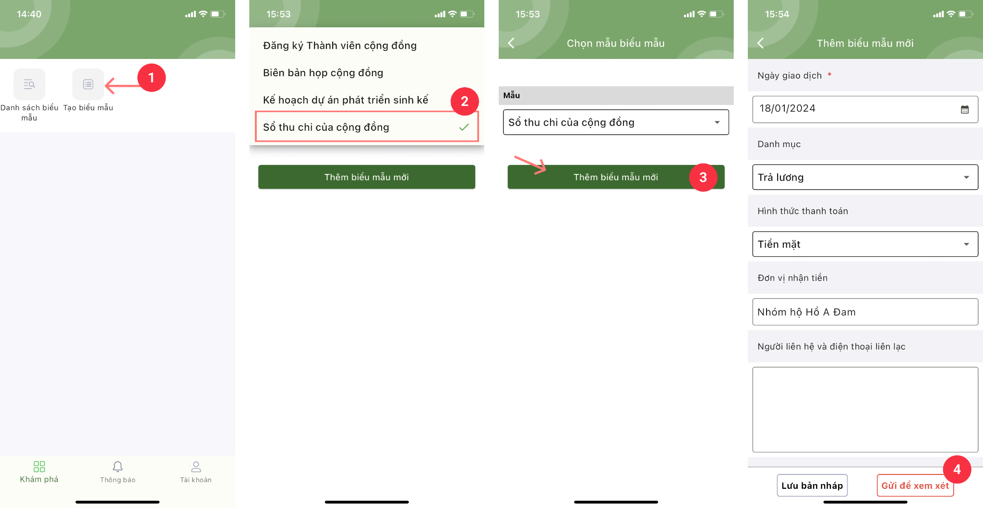

## **3.4. Browse the Livelihood Development Project Plan form**

**Description: Form approved by Commune Owner and Forest Owner**

### 3.4.1. Select browse form from the Notifications screen

Step 1: At the main screen of the app, select the Notification icon.

Step 2: At the Notification screen, click to select the notification of the form to be approved. The app will then display the Edit Form screen.

Step 3: At the Edit form screen, section Confirmation signature of Commune Owner/Forest Owner, click Add signature

Step 4: At the Add signature screen, sign an electronic signature and click Save.

Step 5: At the Edit form screen, click the Approve button.

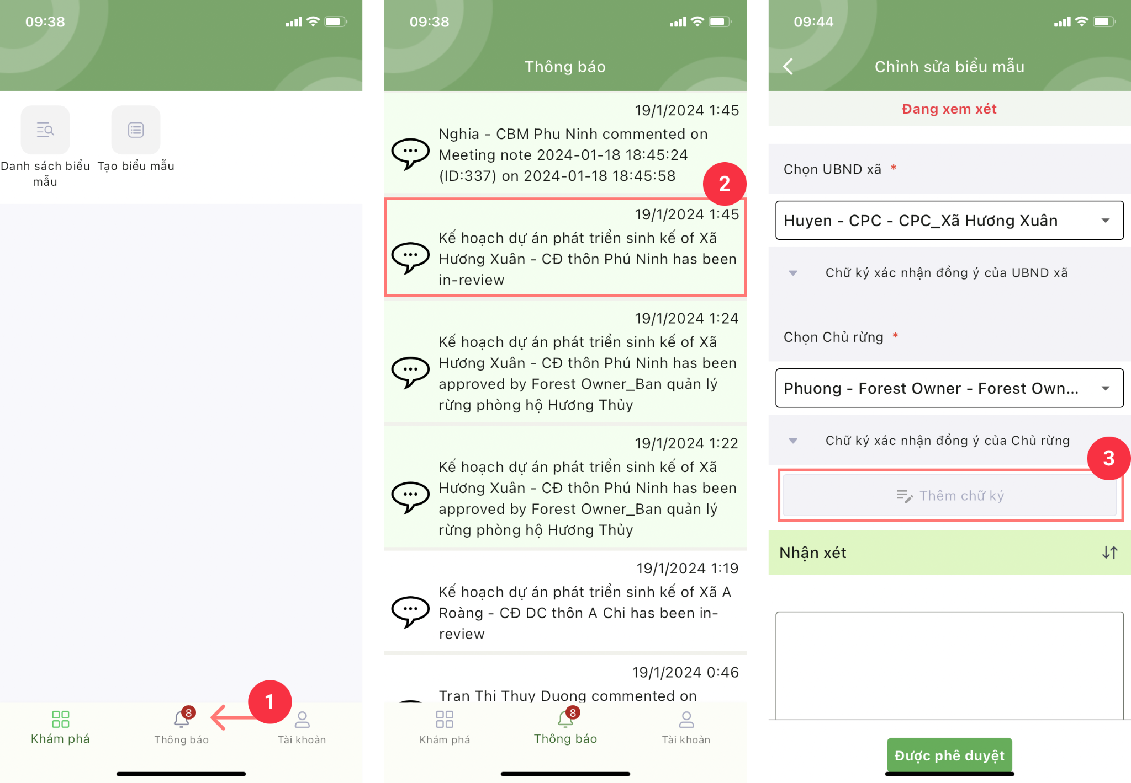

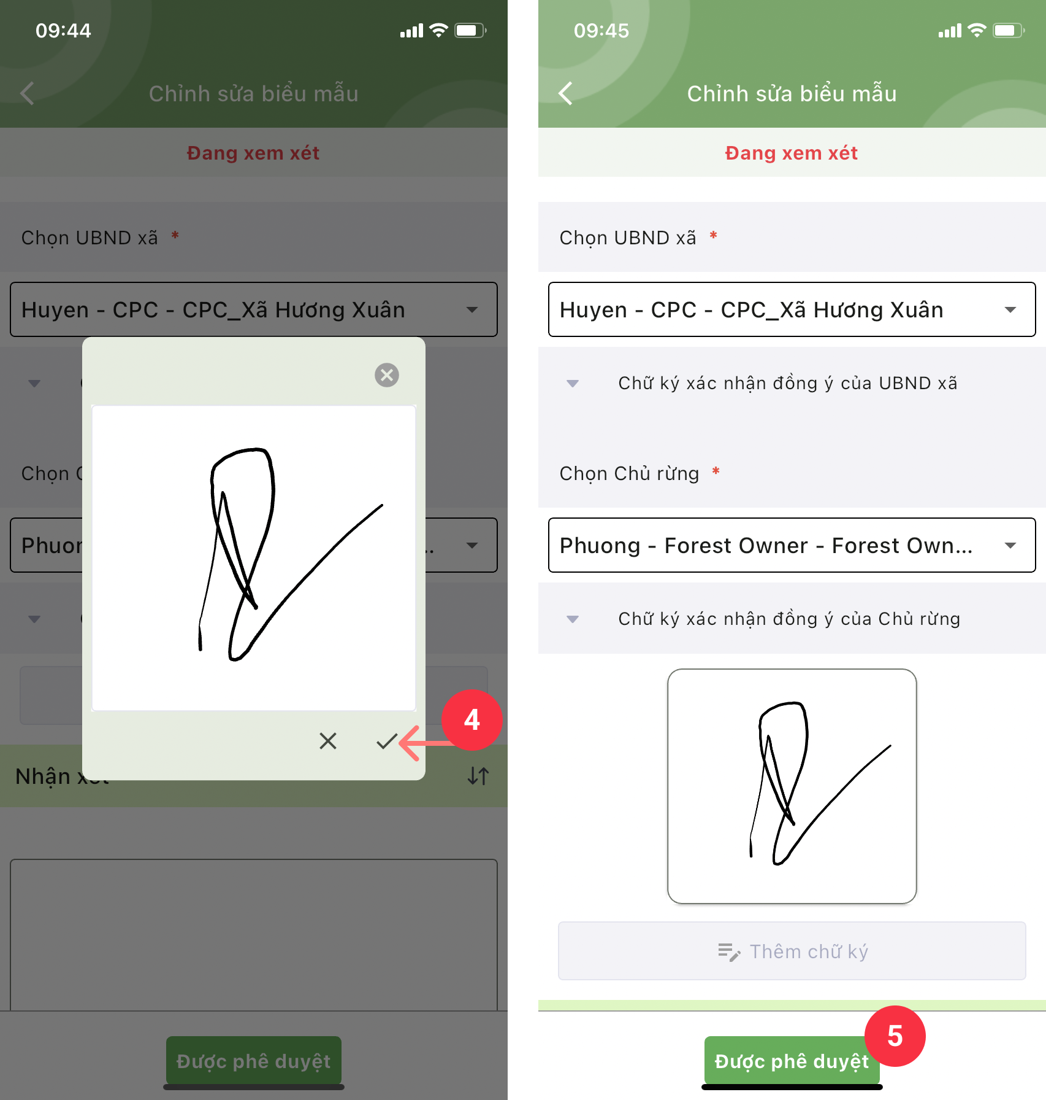

### 3.4.2. Select to approving forms from the List forms screen

Step 1: At the main screen of the app, select the List forms icon.

Step 2: On the List forms screen, select the Livelihood Development project Plan and Budget form. Press the Search button.

Step 3: At the Form List screen, click to select the form you want to approve.

Step 4: At the Edit form screen, section Confirmation signature of Commune Owner/Forest Owner, click Add signature.

Step 5: At the Add signature screen, sign an electronic signature and click Save.

Step 6: At the Edit form screen, click the Approve button.

